Tests
Test # | Test procedure / description | Expected Outcome | Actual Outcome & Remarks | Pass / Fail
1 | Compiles a program used to test the FindFactorsTask class.  - make clean  - make FindFactorsTaskTest  - valgrind ./FindFactorsTaskTest.out | The FindFactorsTaskTest is run and prints out all the numbers that 1000 is divisibe by, and shows that there are no memory leaks | As expected | Pass
2 | Compiles a program used to test the Number class.  - make clean  - make NumberTest  - valgrind ./NumberTest.out | The program is run and valgrind shows that there are no memory leaks | As expected | Pass
3 | Compiles the process version of the application and runs it.  - make clean  - make Processes-Main  - valgrind ./Processes-Main.out 100000 ./file | - The program is run and valgrind shows that there are no memory leaks.  - It also creates a file in the current directory named “file” that contains what was printed to the screen within.  - Output on stdout shows all the factors of 100000 starting at 1, ending at 100000. | As expected | Pass
4 | Compiles the threaded version of the application and runs it.  - make clean  - make Threads-Main  - valgrind ./Threads-Main.out 100000 ./file | Same as test 3 | As expected | Pass

Screenshots
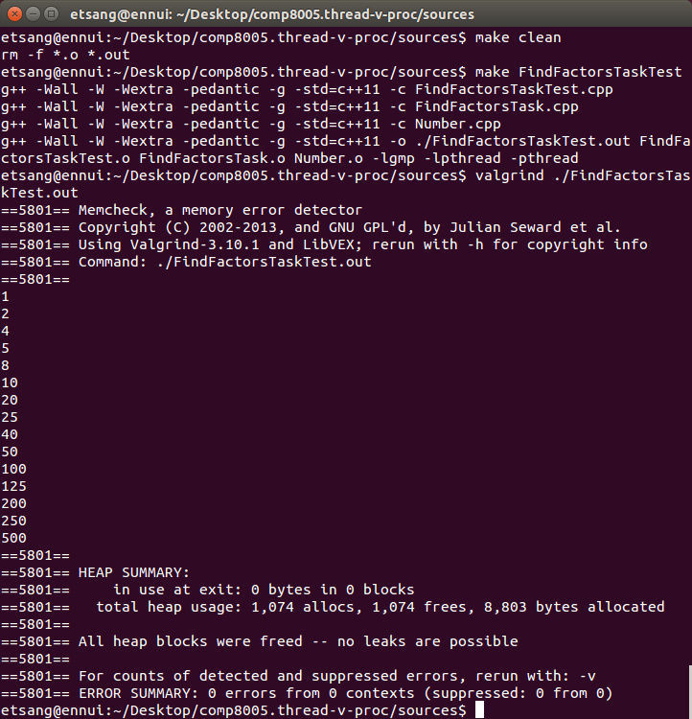Illustration 1: screenshot of test 1
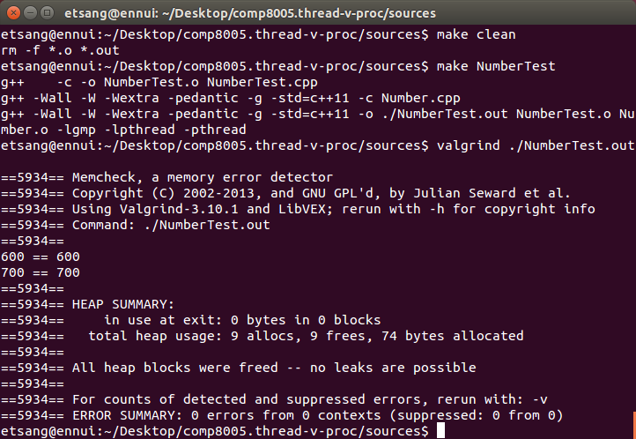Illustration 2: screenshot of test 2
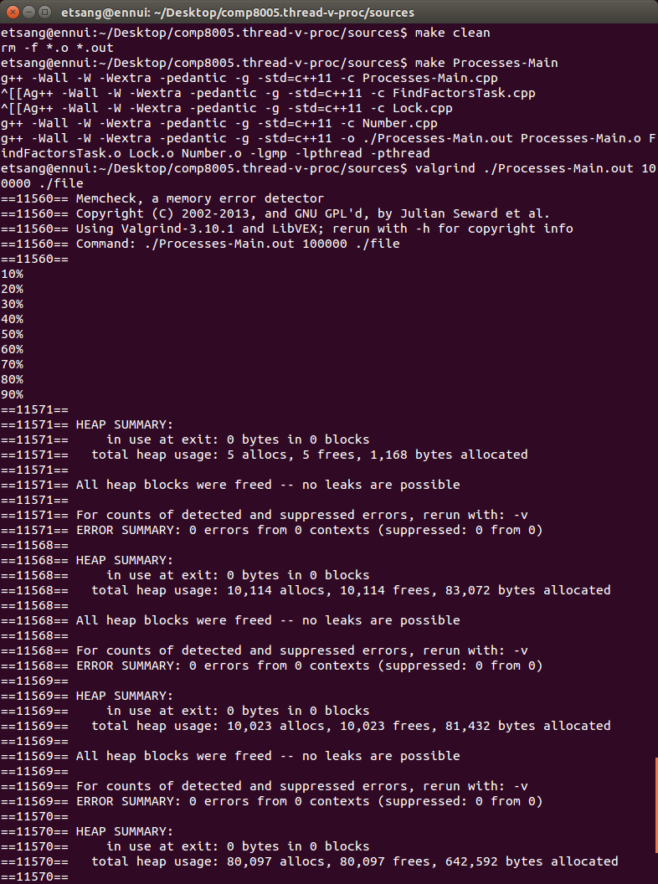Illustration 3: screenshot of test 3 showing clean compile
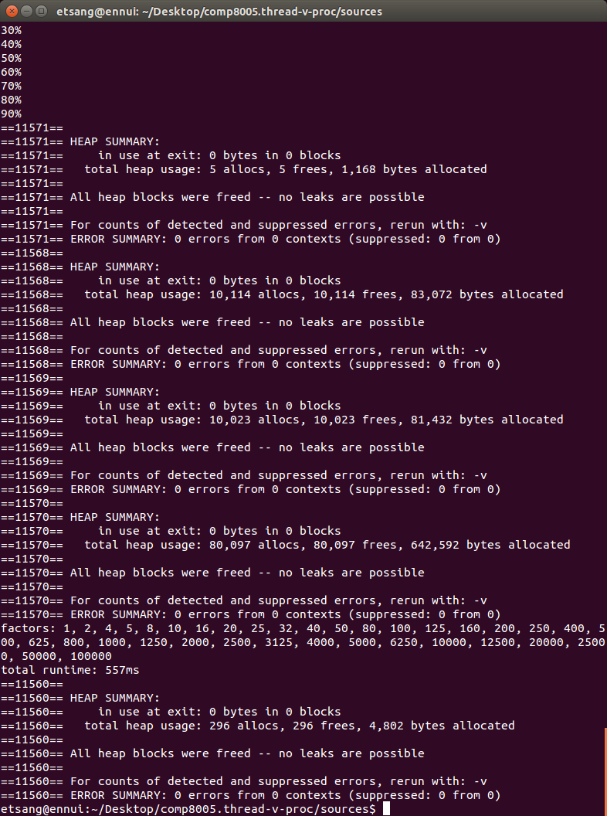Illustration 4: screenshot of test 3, showing zero memory leaks
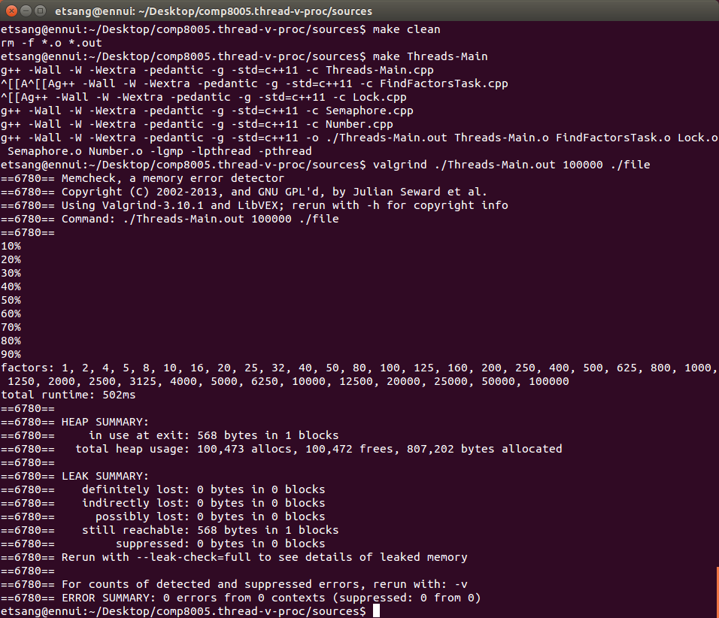Illustration 5: screenshot of test 4 showing clean compile and zero memory leaks
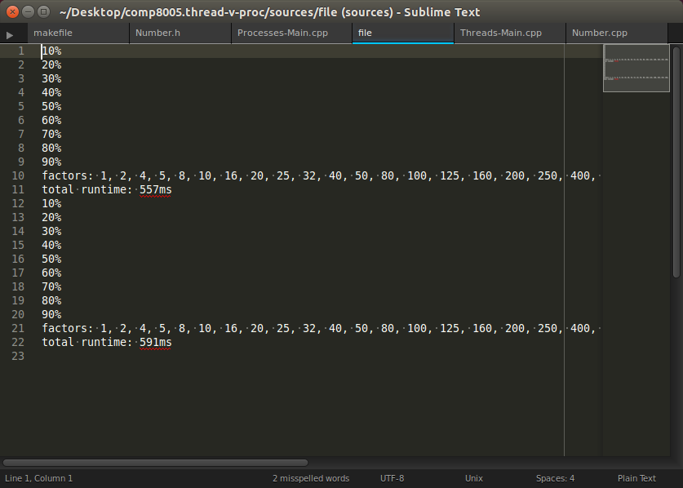Illustration 6: output to file "file" from tests 3 and 4

